Case 3-Eur-Spain-Neolithic-Pendant-Engraved-Anthropomorphic-Silicified Sandstone-3500-2750 BCE

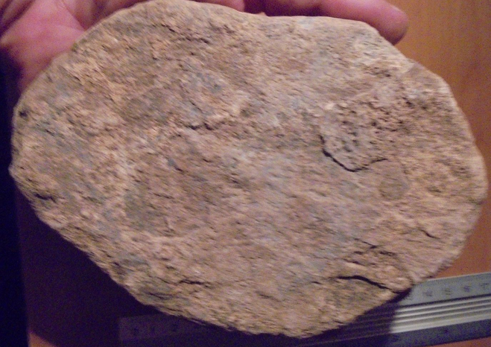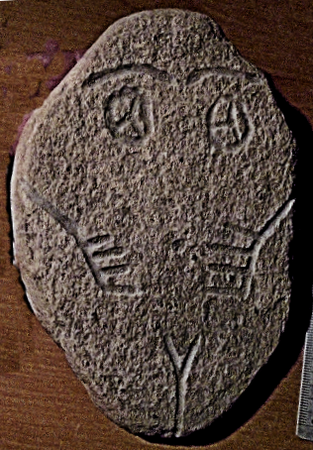

Figs. 1-3. Iberian Engraved Plaque-Female-Anthropomorphic-Silicified Sandstone-3500-2750 BCE

**Case no.: 2**

**Accession Number:**

**Formal Label:** Iberian Engraved Plaque-Female-Anthropomorphic-Silicified Sandstone-3500-2750 BCE

**Display Description:**

Southwestern Iberian (i.e. Southern Portugal and nearby areas of Spain) engraved stone plaques from megalithic funerary monuments dating ca. 3,450–2,750 BCE (calibrated ages) exhibit a common cultural communication system. Apparently, plaques were developed on a basic design grammar, with variable design elements such as caps, eyes, eye brows, and hands, but these variations do not represent any genealogical basis as there is little or no geographical cohesion to the clustering of these specific design features.

**LC Classification:** GN835.S35

**Date or Time Horizon:** Chalcolithic, 3,450–2,750 BCE

**Geographical Area:** Portalegre District in the Alentejo area of south-central Portugal.

**Map:**

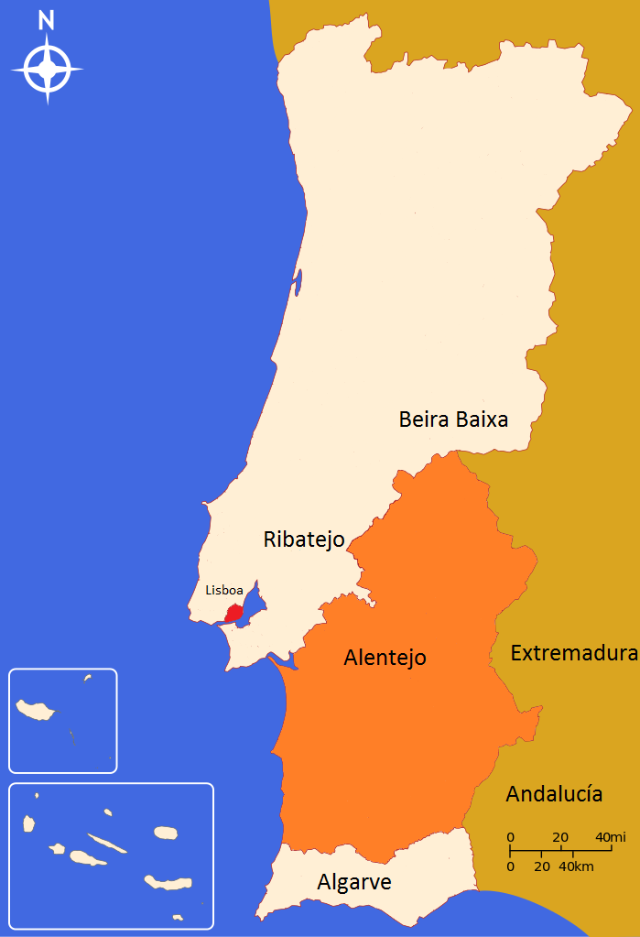 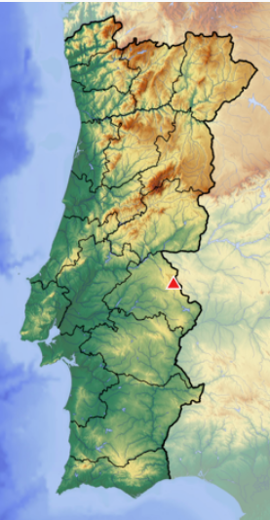

Alentejo area in Portugal By Urgup-tur - Own work, CC BY-SA 4.0, <https://commons.wikimedia.org/w/index.php?curid=43089658>

Portalegre District in the Alentejo area of Portugal after https://upload.wikimedia.org/wikipedia/commons/thumb/0/08/Portugal_location_map_Topographic.png/248px-Portugal_location_map_Topographic.png

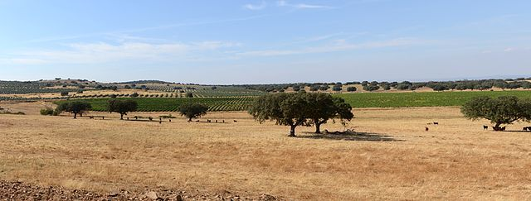

Typical Alentejo landscape (CC by Alvesgaspar) Cork oak trees are in the foreground (*Quercus suber*), in a harvested wheat field. Beyond these are vineyards (*Vitis vinifera*) and olive trees (*Olea europea*. After https://i2.wp.com/upload.wikimedia.org/wikipedia/commons/thumb/2/24/Alentejo_September_2013-1.jpg/640px-Alentejo_September_2013-1.jpg?zoom=2

**GPS coordinates:** [39°17′N 7°21′W](https://tools.wmflabs.org/geohack/geohack.php?pagename=Serra_de_S%C3%A3o_Mamede&params=39_17_N_7_21_W_type:mountain_dim:13km)

**Cultural Affiliation:** Iberian Chacolithic

**Medium:** silicified sandstone

**Dimensions:**

**Weight:**

**Condition: original**

**Provenance:**

**Discussion:**

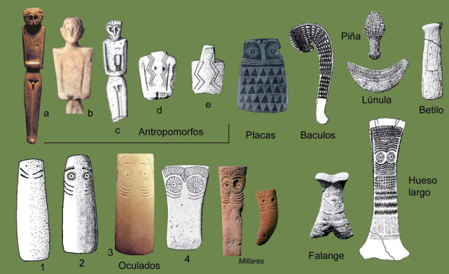

Diverse types of idols from Chalcolithic Iberia after <http://3.bp.blogspot.com/-0d_E0hxg4y4/Tg2RC12l6JI/AAAAAAAAAec/rxtAEz-VFfE/s320/Clasesdeidolillos.webp>

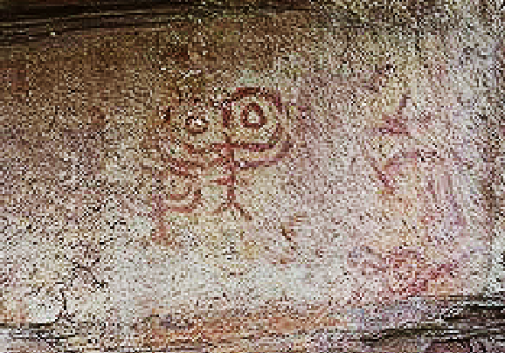

Chacolithic rock art from Abrigo de los Oculados Henarejos, Cuenca province, Spain of the schematic style, possibly IVb. After <http://4.bp.blogspot.com/-yqkUF3EeozY/T98FuRwnIxI/AAAAAAAADeo/rNemjzylTjU/s1600/Abrigo+de+los+Oculados.jpg>

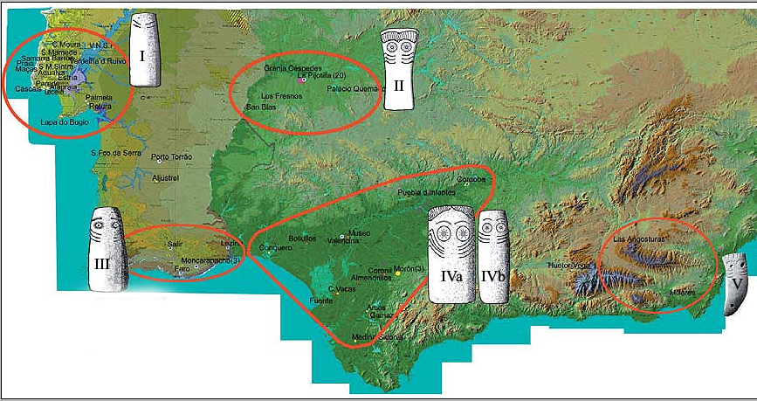

Five zones of different Iberian Chacolithic Eye Plaques. After http://3.bp.blogspot.com/-UCvxmn7GArU/Tg2QVQxuRQI/AAAAAAAAAeY/b8GC-WxD0qQ/s1600/IdolosOculadosAndalucia.webp

The dates for this Iberian Engraved Plaque overlap with the known dates for the Chacolithic Los Millares culture (c 3200–2300 BCE) and its “Almeriense” precursor culture in the municipality of Santa Fe de Mondújar, [Andalucía](https://en.wikipedia.org/wiki/Andaluc%C3%ADa), southeastern Spain. The Chacolithic Los Millares culture probably supported ca 1000 people (Cunliffe 2008: 144; Peregrine and 2001).

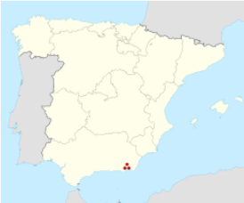 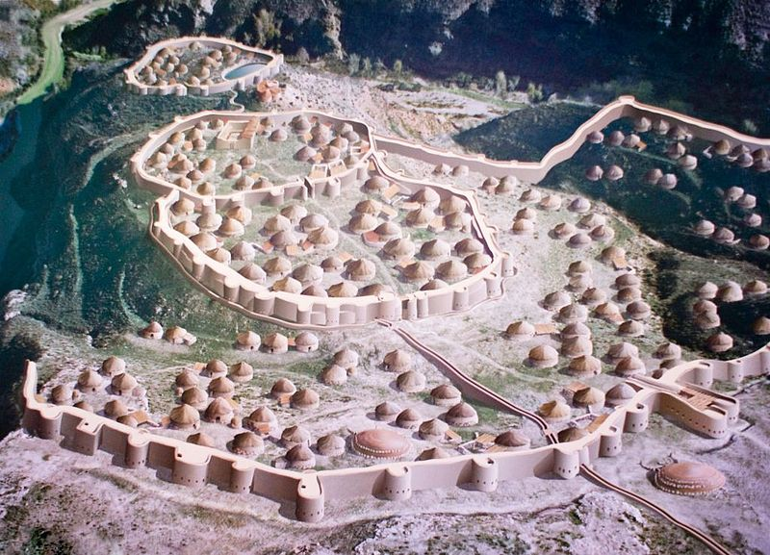

[Santa Fe de Mondújar](https://en.wikipedia.org/wiki/Santa_Fe_de_Mond%C3%BAjar), [Province of Almería](https://en.wikipedia.org/wiki/Province_of_Almer%C3%ADa), [Andalusia](https://en.wikipedia.org/wiki/Andalusia), [Spain](https://en.wikipedia.org/wiki/Spain) [36°57′53″N 02°31′20″W](https://tools.wmflabs.org/geohack/geohack.php?pagename=Los_Millares&params=36_57_53_N_02_31_20_W_type:landmark) after https://upload.wikimedia.org/wikipedia/commons/thumb/8/88/Spain_location_map.svg/250px-Spain_location_map.svg.png

By Jose Mª Yuste, de la fotografía (Tuor123). Miguel Salvatierra Cuenca, autor de la ilustración - Own work, CC BY-SA 4.0, https://commons.wikimedia.org/w/index.php?curid=5505410

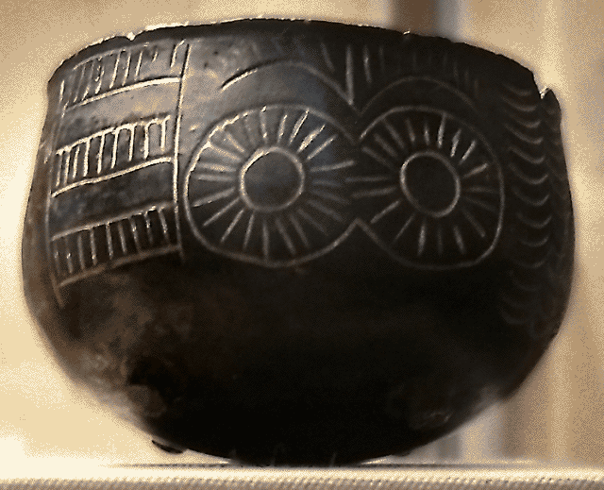

Reproduction of a Millarense bowl with the typical *eyes* motif of the chalcolithic of SE Iberia **after** José-Manuel Benito Álvarez https://upload.wikimedia.org/wikipedia/commons/a/a0/Cuenco_de_Los_Millares.png

**References:**

Cunliffe, Barry. 2008. Europe Between the Oceans, 9000 BC-AD 1000..  New Haven : Yale University Press/

[Peregrine, Peter Neal](https://en.wikipedia.org/wiki/Peter_N._Peregrine); [Ember, Melvin](https://en.wikipedia.org/wiki/Melvin_Ember), eds. 2001. Encyclopedia of Prehistory. 4 : Europe. New York: Springer.

Ruiz, Juan F., Antonio Hernanz, Ruth Ann Armitage, Marvin W. Rowe, Ramon Viñas, José M. Gavira-Vallejo, Albert Rubio, Calcium oxalate AMS 14C dating and chronology of post-Palaeolithic rock paintings in the Iberian Peninsula. Two dates from Abrigo de los Oculados (Henarejos, Cuenca, Spain),” *Journal of Archaeological Science*, 39(8), August 2012, Pages 2655-2667, ISSN 0305-4403, 10.1016/j.jas.2012.02.038. (<http://www.sciencedirect.com/science/article/pii/S0305440312001240>)